**Language and Literature in the Middle Years Programme (MYP)**



**Key Concepts (** Specific Subject Area Concepts**)**

|  |  |  |  |
| --- | --- | --- | --- |
| Aesthetics | Change | Communication** | Communities |
| Connections** | Creativity** | Culture | Development |
| Form | Global Interactions | Identity | Logic |
| Perspective** | Relationships | Time, place and space | Systems |

**Related Concepts**

|  |  |  |  |
| --- | --- | --- | --- |
| Audience Imperatives | Character | Context | Genres |
| Intertextuality | Point of View | Purpose | Self-expression |
| Setting | Structure | Style | Theme |

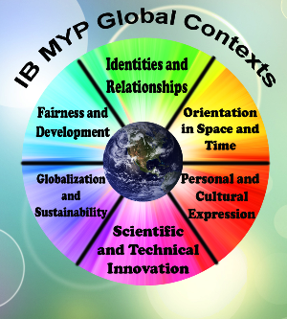

**Language Acquisition in the Middle Years Programme (MYP)**



**Key Concepts (** Specific Subject Area Concepts**)**

|  |  |  |  |  |  |
| --- | --- | --- | --- | --- | --- |
| Aesthetics | Change | Communication** | | Communities | |
| Connections** | Creativity** | Culture** | | Development | |
| Form | Global Interactions | Identity | | Logic | |
| Perspective | Relationships | Time, place and space | | Systems | |
| **Related Concepts** | | | | |
| **Phases 1-2** | | | | |
| Accent | Audience | Context | Conventions | |
| Form | Function | Meaning | Message | |
| Patterns | Purpose | Structure | Word choice | |
| **Phases 3-4** | | | | |
| Audience | Context | Conventions | Empathy | |
| Function | Idiom | Meaning | Message | |
| Point of view | Purpose | Structure | Word choice | |
| **Phases 5-6** | | | | |
| Argument | Audience | Bias | Context | |
| Empathy | Idiom | Inference | Point of view | |
| Purpose | Stylistic choices | Theme | Voice | |



**Individuals and Societies in the Middle Years Programme (MYP)**



**Key Concepts (** Specific Subject Area Concepts**)**

|  |  |  |  |
| --- | --- | --- | --- |
| Aesthetics | Change** | Communication | Communities |
| Connections | Creativity | Culture | Development |
| Form | Global Interactions** | Identity | Logic |
| Perspective | Relationships | Time, place and space** | Systems** |
| ***Related Concepts*** | | | |
| **Economics** | | | |
| Choice | Consumption | Equity | Globalization |
| Growth | Model | Poverty | Power |
| Resources | Scarcity | Sustainability | Trade |
| **History** | | | |
| Causality (Cause and Consequence) | Civilization | Conflict | Cooperation |
| Culture | Governance | Identity | Ideology |
| Innovation and Revolution | Interdependence | Perspective | Significance |
| **Political Science/Civics/Government** | | | |
| Authority | Citizenship | Conflict | Cooperation |
| Globalization | Government | Ideologies | Integration |
| Interdependence | Leadership | Power | Rights |



**Mathematics in the Middle Years Programme (MYP)**



**Key Concepts (** Specific Subject Area Concepts**)**

|  |  |  |  |
| --- | --- | --- | --- |
| Aesthetics | Change | Communication | Communities |
| Connections | Creativity | Culture | Development |
| Form** | Global Interactions | Identity | Logic** |
| Perspective | Relationships** | Time, place and space | Systems |

**Related Concepts**

|  |  |  |  |
| --- | --- | --- | --- |
| Change | Equivalence | Generalization | Justification |
| Measurement | Model | Pattern | Quantity |
| Representation | Simplification | Space | System |



**Sciences in the Middle Years Programme (MYP)**

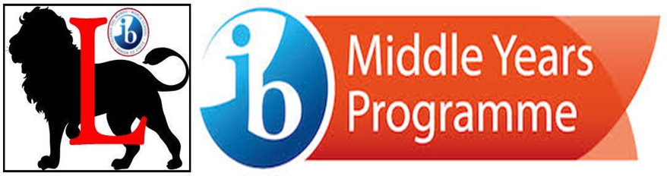

**Key Concepts (** Specific Subject Area Concepts**)**

|  |  |  |  |  |  |
| --- | --- | --- | --- | --- | --- |
| Aesthetics | Change** | | Communication | Communities | |
| Connections | Creativity | | Culture | Development | |
| Form | Global Interactions | | Identity | Logic | |
| Perspective | Relationships** | | Time, place and space | Systems** | |
| **Related Concepts Biology** | | | | | | |
| Balance | | Environment | | | Transformation | |
| Consequences | | Energy | | | Evidence | |
| Form | | Function | | | Interaction | |
| Models | | Movement | | | Patterns | |
| **Physics** | | | | | | |
| Development | | Environment | | | Transformation | |
| Consequences | | Energy | | | Evidence | |
| Form | | Function | | | Interaction | |
| Models | | Movement | | | Patterns | |
| **Chemistry** | | | | | | |
| Balance | | Conditions | | | Transfer | |
| Consequences | | Energy | | | Evidence | |
| Form | | Function | | | Interaction | |
| Models | | Movement | | | Patterns | |



**Design in the Middle Years Programme (MYP)**



**Key Concepts (** Specific Subject Area Concepts**)**

|  |  |  |  |
| --- | --- | --- | --- |
| Aesthetics | Change | Communication** | Communities** |
| Connections | Creativity | Culture | Development** |
| Form | Global interactions | Identity | Logic |
| Perspective | Relationships | Time, place and space | Systems** |

**Related Concepts**

|  |  |  |  |
| --- | --- | --- | --- |
| Adaptation | Collaboration | Ergonomics | Evaluation |
| Form | Function | Innovation | Invention |
| Markets and Trends | Perspective | Resources | Sustainability |



**Physical and Health Education in the Middle Years Programme (MYP)**



**Key Concepts (** Specific Subject Area Concepts**)**

|  |  |  |  |
| --- | --- | --- | --- |
| Aesthetics | Change** | Communication** | Communities |
| Connections | Creativity | Culture | Development |
| Form | Global interactions | Identity | Logic |
| Perspective | Relationships** | Time, place and space | Systems |

**Related Concepts**

|  |  |  |  |
| --- | --- | --- | --- |
| Adaptation | Balance | Choice | Energy |
| Environment | Function | Interaction | Movement |
| Perspectives | Refinement | Space | Systems |



**Visual Arts in the Middle Years Programme (MYP)**



**Key Concepts (** Specific Subject Area Concepts**)**

|  |  |  |  |
| --- | --- | --- | --- |
| Aesthetics** | Change** | Communication** | Communities |
| Connections | Creativity | Culture | Development |
| Form | Global interactions | Identity** | Logic |
| Perspective | Relationships | Time, place and space | Systems |

**Related Concepts**

|  |  |  |  |
| --- | --- | --- | --- |
| Audience | Boundaries | Composition | Expression |
| Genre | Innovation | Interpretation | Narrative |
| Presentation | Representation | Style | Visual Culture |

